**ME 8710: Assignment 7**

**Question 1:**

**Q1)**

1. **DFS**

|  |  |  |  |  |  |  |  |  |  |  |  |  |  |
| --- | --- | --- | --- | --- | --- | --- | --- | --- | --- | --- | --- | --- | --- |
| **3** | **2** |  |  | **10** |  |  | **14** | **15** | **16** | **17** | **18** | **19** | **20** |
| **4** | **(S) 1** | **7** | **8** | **9** | **11** | **12** | **13** |  |  |  |  |  | **21** |
| **5** | **6** |  |  |  |  |  |  |  |  |  |  |  | **22** |
|  |  |  |  |  |  |  |  |  | **(G) 31** | **30** | **29** | **28** | **23** |
|  |  |  |  |  |  |  |  |  |  |  |  |  | **24** |
|  |  |  |  |  |  |  |  |  |  |  | **27** | **26** | **25** |

**Number of Steps: 21**

**Total Number of Nodes: 31**

1. **BFS**

|  |  |  |  |  |  |  |  |  |  |  |  |  |  |
| --- | --- | --- | --- | --- | --- | --- | --- | --- | --- | --- | --- | --- | --- |
| **6** | **2** |  |  | **10** |  |  | **17** | **21** | **26** | **30** | **34** | **38** | **42** |
| **5** | **(S) 1** | **3** | **7** | **9** | **11** | **13** | **15** | **18** | **22** | **27** | **31** | **35** | **39** |
| **8** | **4** |  |  | **12** |  |  | **19** |  |  |  |  |  | **43** |
|  |  |  |  | **14** |  |  | **23** |  | **(G) 46** |  |  |  | **45** |
| **41** |  |  |  | **16** |  |  |  |  | **44** |  |  |  |  |
| **37** | **33** | **29** | **25** | **20** | **24** | **28** | **32** | **36** | **40** |  |  |  |  |

**Number of Steps: 15**

**Total Number of Nodes: 46**

1. **A\***

|  |  |  |  |  |  |  |  |  |  |  |  |  |  |
| --- | --- | --- | --- | --- | --- | --- | --- | --- | --- | --- | --- | --- | --- |
|  | **2** |  |  | **9** |  |  | **16** | **19** | **22** | **26** | **30** |  |  |
| **5** | **(S) 1** | **3** | **6** | **8** | **10** | **12** | **14** | **17** | **20** | **23** | **27** | **31** |  |
| **7** | **4** |  |  | **11** |  |  | **18** |  |  |  |  |  |  |
|  |  |  |  | **13** |  |  | **21** |  | **(G) 37** |  |  |  |  |
|  |  |  |  | **15** |  |  |  |  | **36** |  |  |  |  |
|  |  |  | **29** | **25** | **28** | **32** | **33** | **34** | **35** |  |  |  |  |

**Number of Steps: 15**

**Total Number of Nodes: 37**

|  |  |  |  |  |  |  |
| --- | --- | --- | --- | --- | --- | --- |
| **node** | **g(n)** | **horizontal cells** | **vertical cells** | **h(n)** | **f(n)** |  |
| **1** | **0** | **8** | **2** | **9.998** | **9.998** | **expand to node 2,3,4,5** |
| **2** | **1** | **8** | **3** | **10.997** | **11.997** | **expand to node 24** |
| **3** | **1** | **7** | **2** | **8.998** | **9.998** | **expand to node 6** |
| **4** | **1** | **8** | **1** | **8.999** | **9.999** | **expand to node 7** |
| **5** | **1** | **9** | **2** | **10.998** | **11.998** |  |
| **6** | **2** | **6** | **2** | **7.998** | **9.998** | **expand to node 8** |
| **7** | **2** | **9** | **1** | **9.999** | **11.999** |  |
| **8** | **3** | **5** | **2** | **6.998** | **9.998** | **expand to node 9,10,11** |
| **9** | **4** | **5** | **3** | **7.997** | **11.997** |  |
| **10** | **4** | **4** | **2** | **5.998** | **9.998** | **expand to node 12** |
| **11** | **4** | **5** | **1** | **5.999** | **9.999** | **expand to node 13** |
| **12** | **5** | **3** | **2** | **4.998** | **9.998** | **expand to node 14** |
| **13** | **5** | **5** | **0** | **5.000** | **10.000** | **expand to node 15** |
| **14** | **6** | **2** | **2** | **3.998** | **9.998** | **expand to node 16,17,18** |
| **15** | **6** | **5** | **1** | **5.999** | **11.999** | **expand to node 25** |
| **16** | **7** | **2** | **3** | **4.997** | **11.997** |  |
| **17** | **7** | **1** | **2** | **2.998** | **9.998** | **expand to node 19,20** |
| **18** | **7** | **2** | **1** | **2.999** | **9.999** | **expand to node 21** |
| **19** | **8** | **1** | **3** | **3.997** | **11.997** |  |
| **20** | **8** | **0** | **2** | **1.998** | **9.998** | **expand to node 22,23** |
| **21** | **8** | **2** | **0** | **2.000** | **10.000** |  |
| **22** | **9** | **0** | **3** | **2.997** | **11.997** | **expand to node 26** |
| **23** | **9** | **1** | **2** | **2.998** | **11.998** | **expand to node 27** |
| **24** | **2** | **9** | **3** | **11.997** | **13.997** |  |
| **25** | **7** | **5** | **2** | **6.998** | **13.998** | **expand to node 28,29** |
| **26** | **10** | **1** | **3** | **3.997** | **13.997** | **expand to node 30** |
| **27** | **10** | **2** | **2** | **3.998** | **13.998** | **expand to node 31** |
| **28** | **8** | **4** | **2** | **5.998** | **13.998** | **expand to node 32** |
| **29** | **8** | **6** | **2** | **7.998** | **15.998** |  |
| **30** | **11** | **2** | **3** | **4.997** | **15.997** |  |
| **31** | **11** | **3** | **2** | **4.998** | **15.998** |  |
| **32** | **9** | **3** | **2** | **4.998** | **13.998** | **expand to node 33** |
| **33** | **10** | **2** | **2** | **3.998** | **13.998** | **expand to node 34** |
| **34** | **11** | **1** | **2** | **2.998** | **13.998** | **expand to node 35** |
| **35** | **12** | **0** | **2** | **1.998** | **13.998** | **expand to node 36** |
| **36** | **13** | **0** | **1** | **0.999** | **13.999** | **expand to node 37** |
| **37** | **14** | **0** | **0** | **0.000** | **14.000** | **solution reached** |

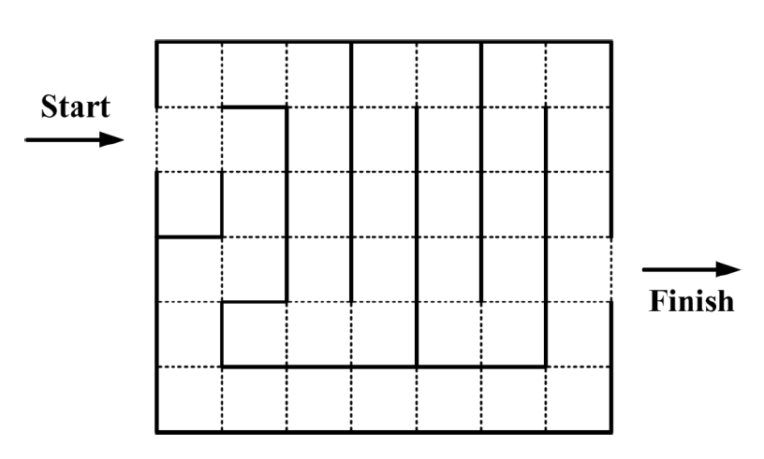**Q2)**

**9**

**7**

**6**

**5**

**3**

**4**

**8**

**2**

**1**

**10**

**a). A* will guarantee the solution for the above problem.**

|  |  |  |  |  |  |  |
| --- | --- | --- | --- | --- | --- | --- |
| **node** | **g(n)** | **horizontal cells** | **vertical cells** | **h(n)** | **f(n)** |  |
| **1** | **0** | **6** | **2** | **8.000** | **8.000** | **expand to node 2,3,4** |
| **2** | **1** | **6** | **3** | **9.000** | **10.000** | **expand to node 8** |
| **3** | **1** | **6** | **1** | **7.000** | **8.000** | **x** |
| **4** | **1** | **5** | **2** | **7.000** | **8.000** | **expand to node 5** |
| **5** | **2** | **5** | **1** | **6.000** | **8.000** | **expand to node 6** |
| **6** | **3** | **5** | **0** | **5.000** | **8.000** | **expand to node 7** |
| **7** | **4** | **6** | **0** | **6.000** | **10.000** | **expand to node 9** |
| **8** | **2** | **5** | **3** | **8.000** | **10.000** | **expand to node 10** |
| **9** | **5** | **6** | **1** | **7.000** | **12.000** |  |
| **10** | **3** | **4** | **3** | **7.000** | **10.000** |  |